Lido JUNIOR Cookers

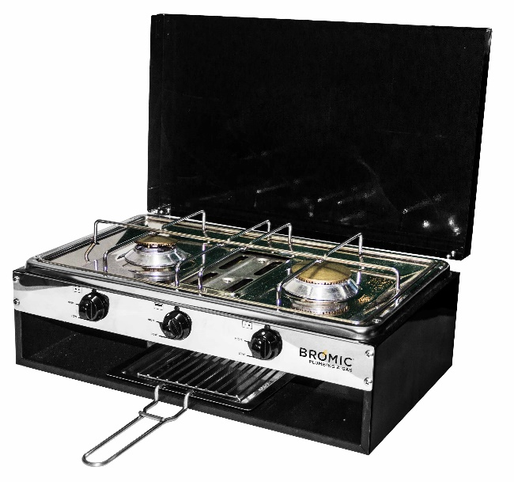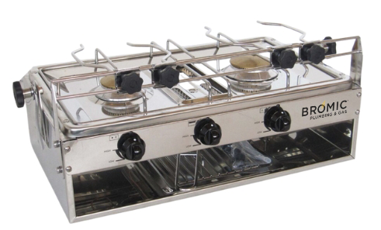

No. | Description | Use
2020068* | Lido Junior Caravan 2 Burner with Grill and Flame Failure | Caravans or mobile homes
2020069-1* | Lido Junior Marine 2 Burner with Grill and Gimble | Marine use, Caravans or mobile homes
*Does not include hose or regulator

Specifications
- 12 months warranty
- Includes flame safeguard on each burner – when flame goes out, gas turns off.
- Knob for adjustable flame control. high and low
- Small/left burner -> Injector size: 0.65mm. Gas consumption: 5.7MJ/hr
- Large/right burner -> Injector size: 0.75mm. Gas consumption: 7.2MJ/hr
- Grill gas consumption: 4.8MJ/hr
- HxWxD: 170 x 500 x 280 mm
- Weight 6.5kg (2020068*)/ 7kg (2020069-1*)
- Max hose length allowed is 1200mm

FAQs
Which hose + regulator fit? Max hose length allowed is 1200mm.
- PVC hose and regulator kit: use code 6260514 for 1.2m hose
- PVC hose and regulator with elbow adaptor: 6HGB1200 + 6060411H + 1410698
- Bayonet: (only for LPG) use code 10HIS1000 for 1m hose to fit.
Can I install this cooker in my caravan? installing a cooker in a caravan or boat must be done in accordance with AS5601 and be done by a licensed gas fitter.
What approvals does it have? Global Mark GAS-100177-004.
How high does the sea rail go up the pot? Pot holder is 4.5cm above the burner.
How are the pots held stable on the marine cooker? There is a rail attached to the front and adjustable clamps are attached so that it holds different sizes pots.
How do I light it? Burner: Press knob in and turn anticlockwise to high to release gas. Light gas with an external flame such as a lighter or match. Grill: Press knob in and turn anticlockwise to high to release gas. Light gas under hob with an external flame such as a lighter or match.
How to cook toast? Turn grille to high and put bread underneath, on tray rack.
How to clean? Wait to it to cool. Use warm soapy water and soft cloth – no abrasives. Pg 4 of manual
Clearances? If it is installed – minimum of 200mm from centre of the top of the gas burners to any combustible surface on each side and back of cooker. Minimum of 600mm to overhead cupboard above the cooker.
Can it be converted to NG? No, this has only been approved for LPG and should not be converted.
Flame blows out quickly? Occurs after initial setup due to air in the lines. Open valves and allow to fill with gas.

Spare Parts
No. | Description
2020094 | Lido Jnr brass Gas adaptor M16x5/16 SAE Parker
2020072 | Thermocouple Parker Burner 220mm for Lido JR
2020103 | Lido Jnr Door Hinge Assembly Parker
2020107 | Lido Jnr Grill Tray Grid Parker
2020113 | Lido Jnr Chromed Pan Support Parker
2020114 | Lido Jnr Top Panel Parker
2020127 | Lido Jnr Cooker Knob Parker
2020129 | Lido Jnr Grill Tray Parker
2020130 | Lido Jnr Grill Tray Handle Parker
2020308 | Lido Jnr Burner (Sml) Parker
2020311 | Lido Jnr Burner (Lge) Parker
2020319 | Lido Jnr Gascock/Inj R/F 0.75mm Parker
2020320 | Lido Jnr G/Burner G/Cock 0.63mm Parker
2020321 | Lido Jnr Gascock/Inj L/F 0.65mm Parker
2020325 | Lido Jnr Grill Burner Assem Parker
2020327 | Bromic Lido Cooker Lid With Hinges
2020328 | Bromic Lido Cooker Rubber Feet Pack Of 4

Installation Instructions – from manual

General
- Install according to AS5601
- A manual shut off valve must be installed in an accessible position external to the range.
- Check for leaks after installation. Turn knobs to ‘off’ open gas valve and check there are no leaks with soapy water. – tighten fittings if leaks occur.
- Check for clean blue flames (not yellow)

Feet
- Push plastic feet into base of cooker (it will shred the pins so they are tightly fitted. They shouldn’t be removed and reinstalled)

Rear Bracket
- Used to secure to table
- Using a power screw driver, screw bracket into preexisting holes with 2 small pointed screws
- Screw onto table using separate M5 screws as there is a clearance hole of 6mm and the required length for the surface.

Sea Rail for Marine
- Using a handheld screwdriver, screw rail into side of cooker using the 2 screws on each side, with the washer under the head of the screw. Screw in until rail is secure.
- Using black flower-like knobs, screw clamps onto rail so it fits around the bars and is able to clamp around a pot on each burner. (bracket can be over or under the screw – both will work)
- Clamps are adjustable and can slide along the rail depending on the pot used.

Gimble for Marine
- Hold bracket with 3 threaded holes on inside of cooker wall. Screw gimble onto side of cooker so all the 3 holes line up. The washers should again be under the heads of the screws.
- The black flower-like handle can be easily tightened or loosened. Using separate M5 screws as there is a clearance hole of 6mm, screw into hanging supports using the 2 predrilled holes to secure to supports. Loosen black handles so that the cooker can swing on the gimble in line with the rocking of the boat.

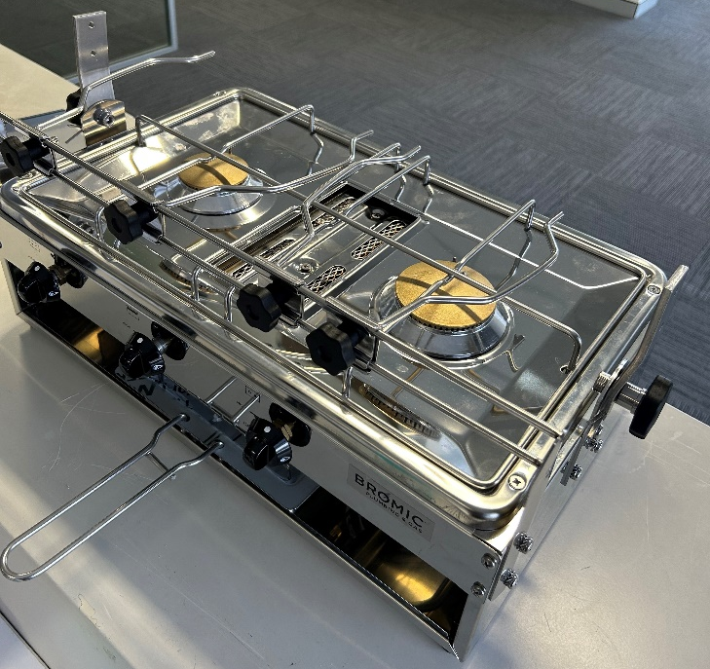

END TECHNICAL DATA SHEET

